# Lab 8: More Reusable Components

## Objectives

*  Create another reusable component
*  Render the reusable component

## Steps

### Create another reusable component

1. Create the file src\projects\ProjectCard.js.
2. Implement a ProjectCard as a **function** (not class) component that meets the following specifications:
   1. Takes a project object as a prop.
   2. Cut the <div className="card">...</div> from the ProjectList component and use it as the JSX for the ProjectCard component.
   3. Add a function to format the description to 60 characters and call it when rendering the description.

#### src\projects\ProjectCard.js

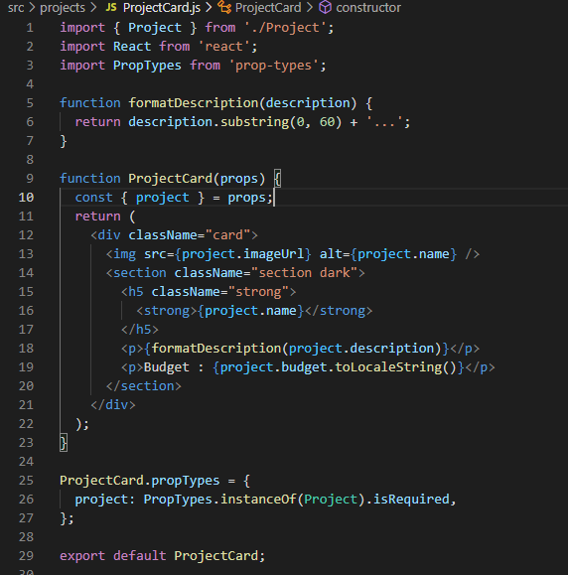

### Render the reusable component

1. Open the file src\projects\ProjectList.js.
2. Render the ProjectCard component passing it the project as a prop.

#### src\projects\ProjectList.js

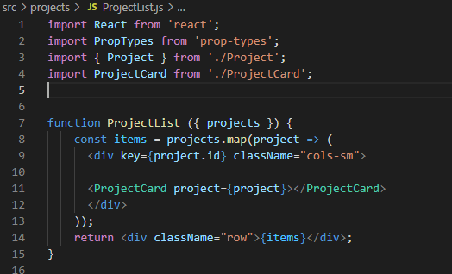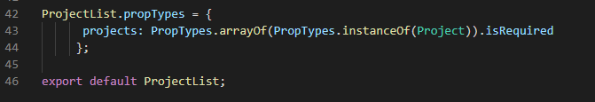

1. **Verify** the **project** **data** **displays** correctly (it should still look the same as it did in the last lab except for the ... after the description) in the browser.



### ✔ You have completed Lab 8